Match Graph With the Equation

1. f(x)=−(x+3)(x+2)(x−1)(x−1) | A  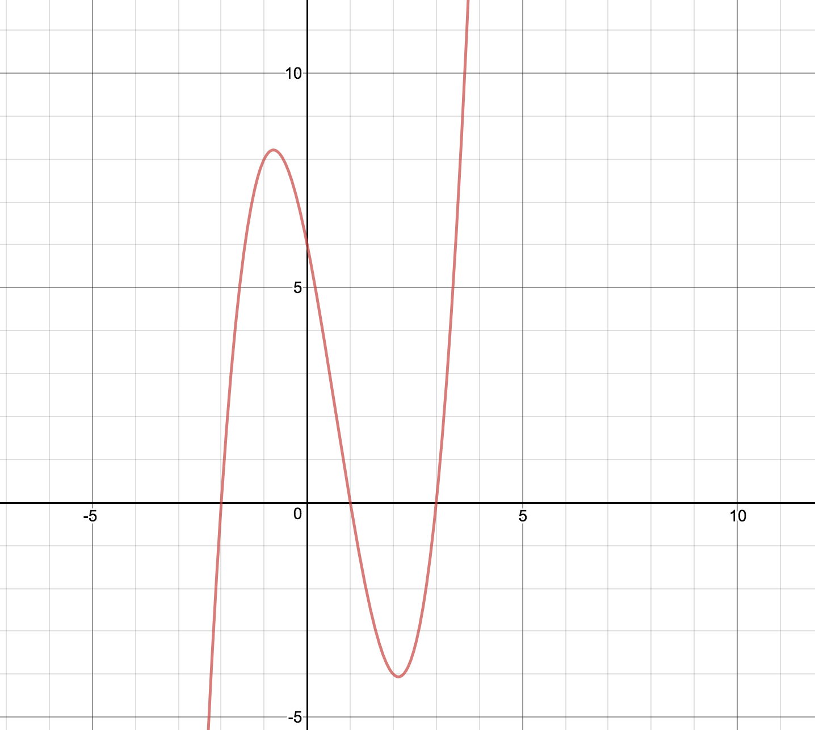
2. f(x)=(x+3)(x+2)(x−1) | B  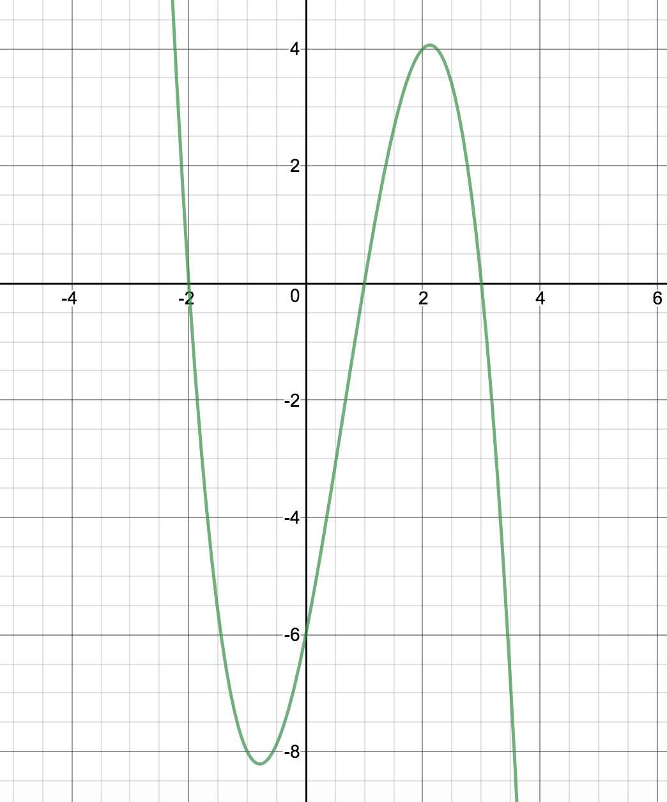
3. f(x)=(x−3)(x+2)(x−1) | C  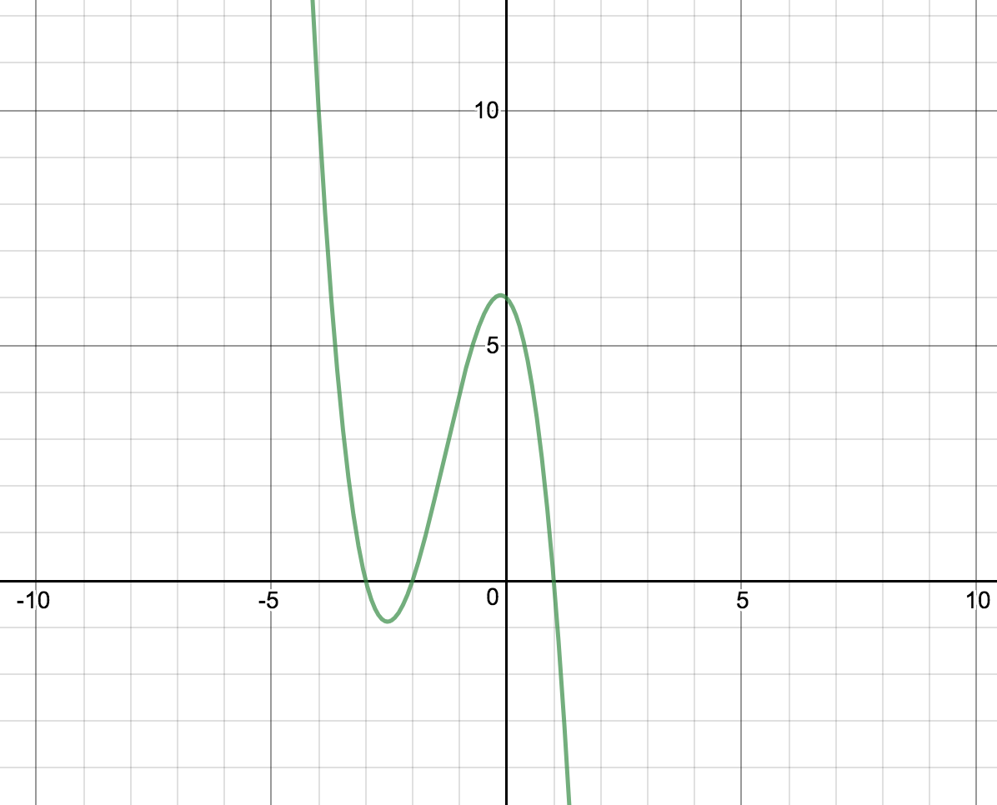
4. f(x)=−(x+3)(x+2)(x−1) | D  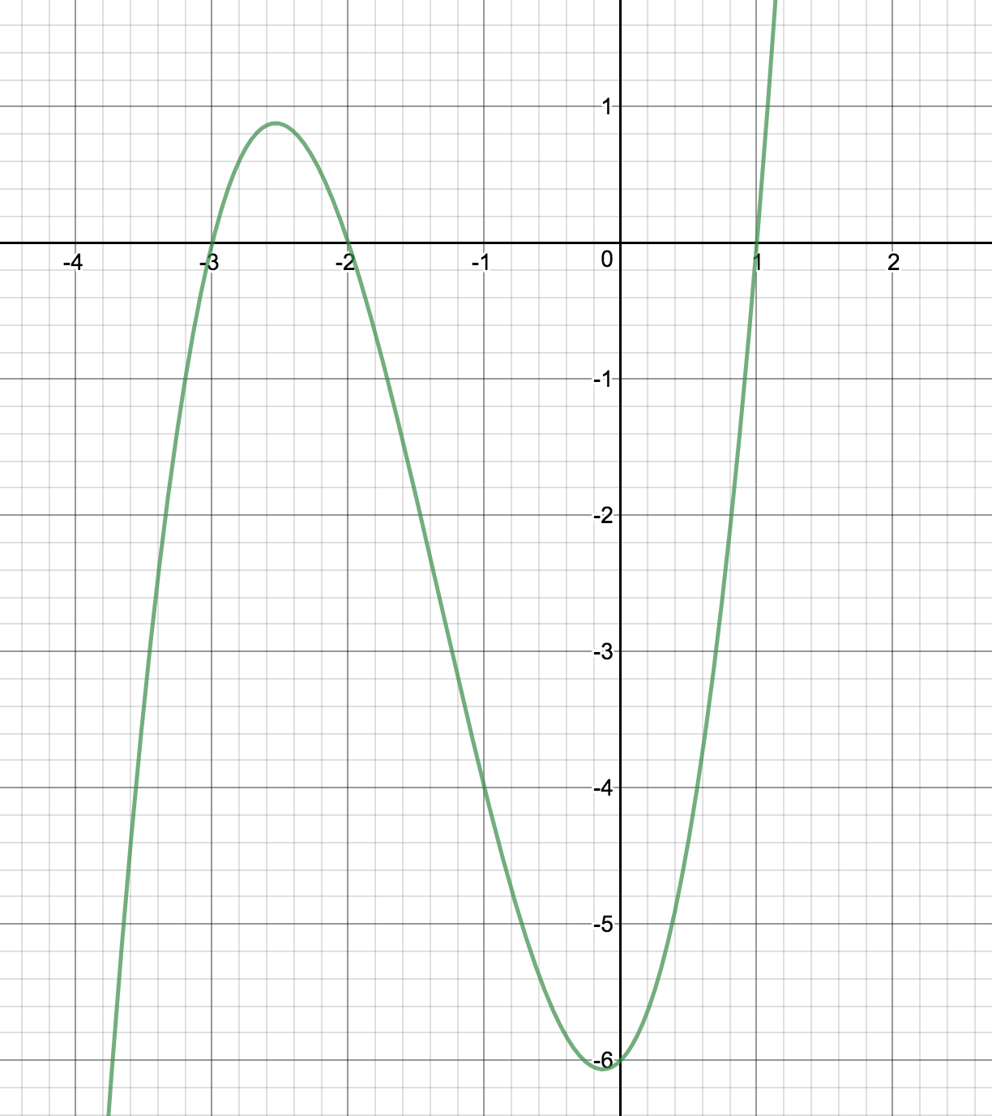
5. f(x)=−(x+3)(x+3)(x−1)(x−1) | E  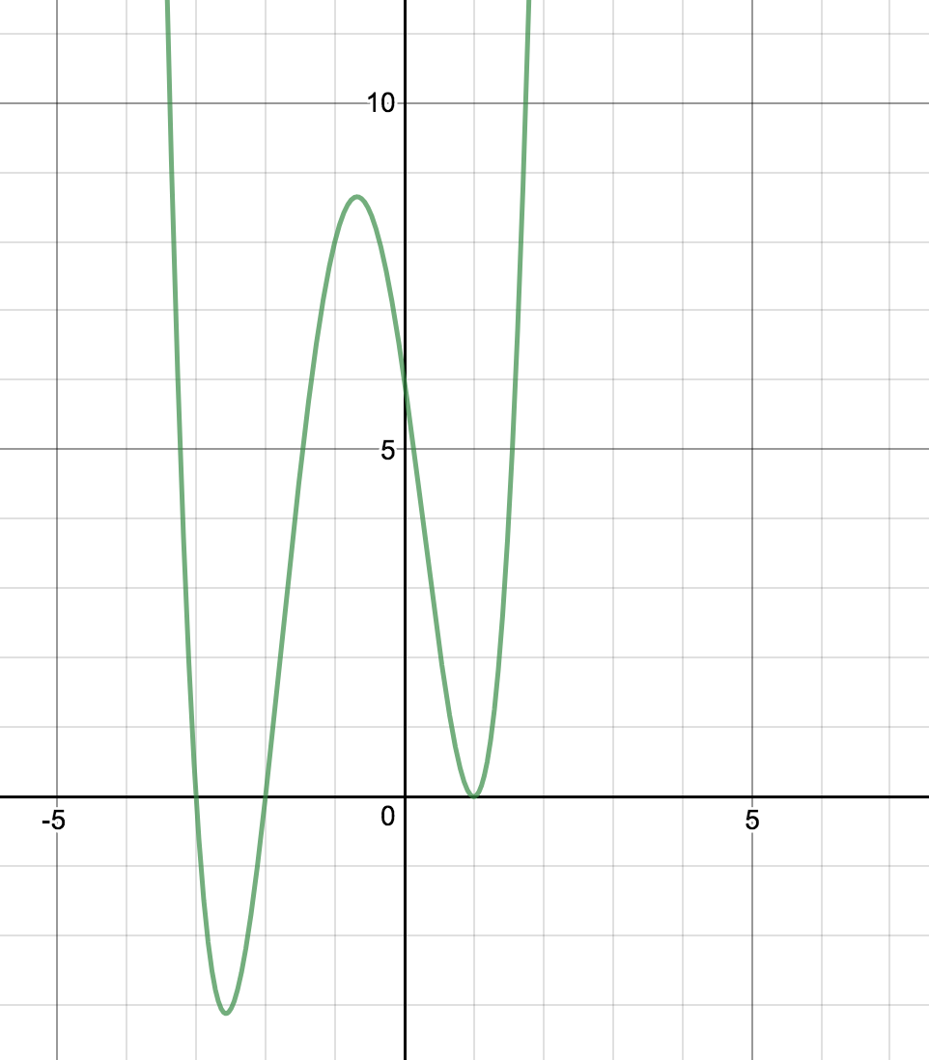
6. ) f(x)=−(x−3)(x+2)(x−1) | F  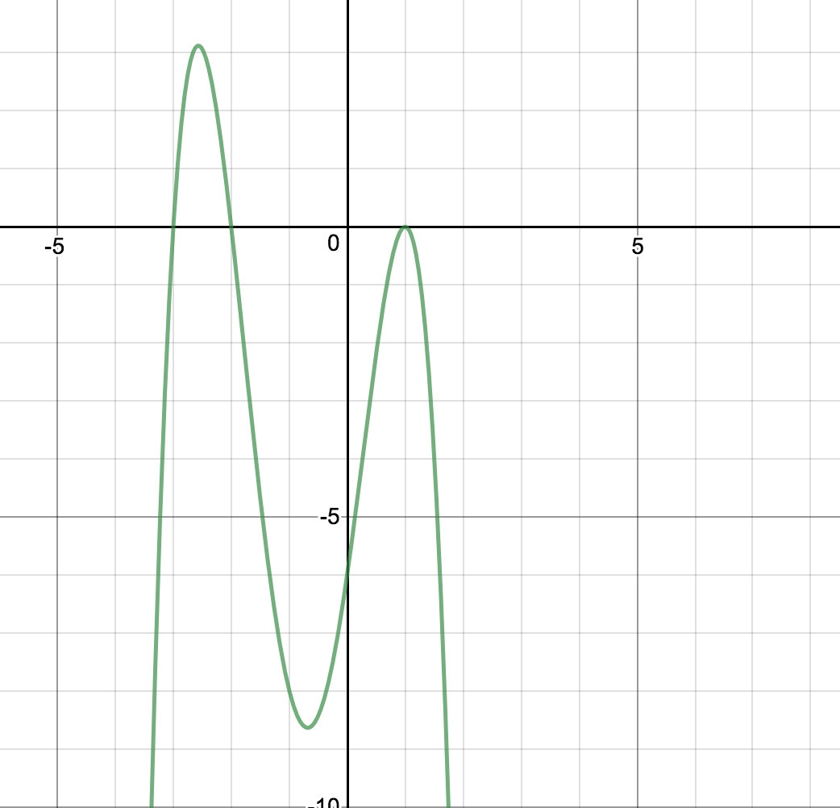
7. f(x)=34(x+3)(x−1) | G
8. f(x)=(x+3)(x+2)(x−1) | H  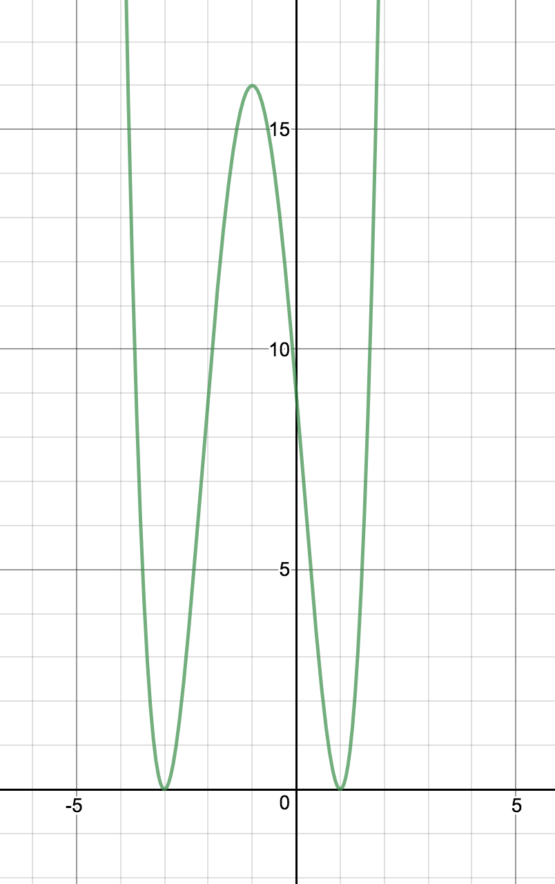
9. f(x)=(x+3)(x+2)(x−1)(x−1) | I  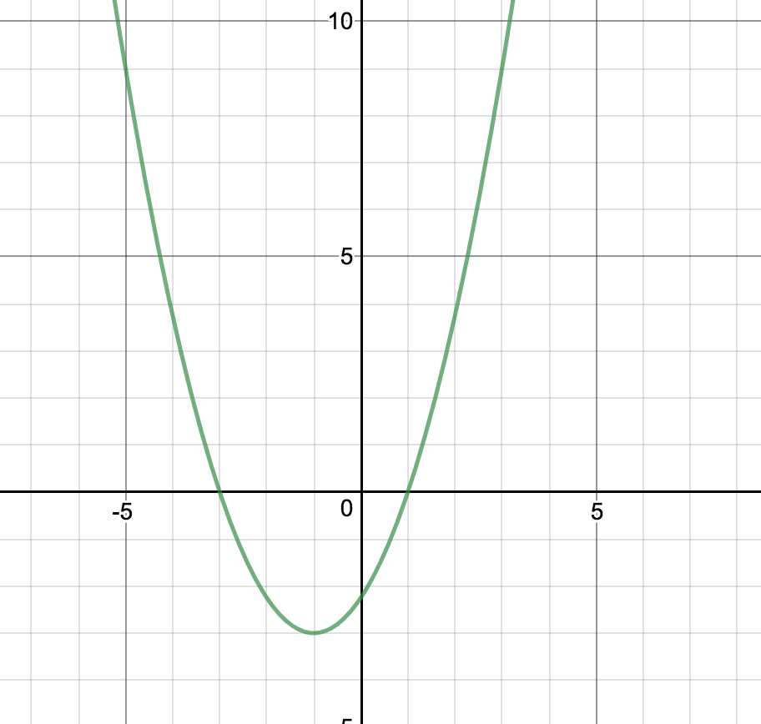
10. f(x)=34(x+3) | J  